DISPLAY POP UP WHEN THERE IS A POLICY VIOLATION BEFORE SUBMITTING A REQUEST

>go to LCM PROIVSIONING WORKFLOW and change the variable policyScheme to interactive

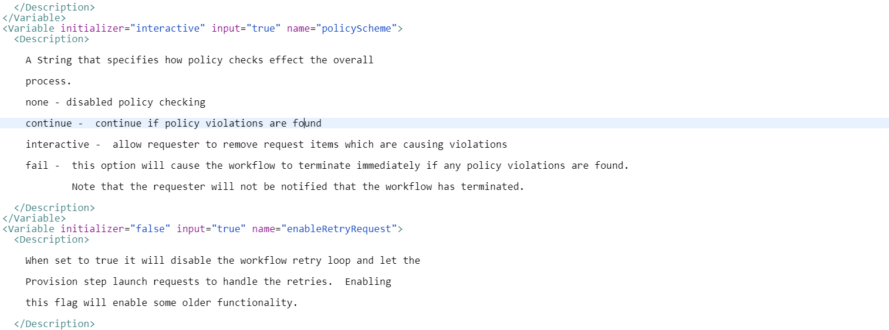



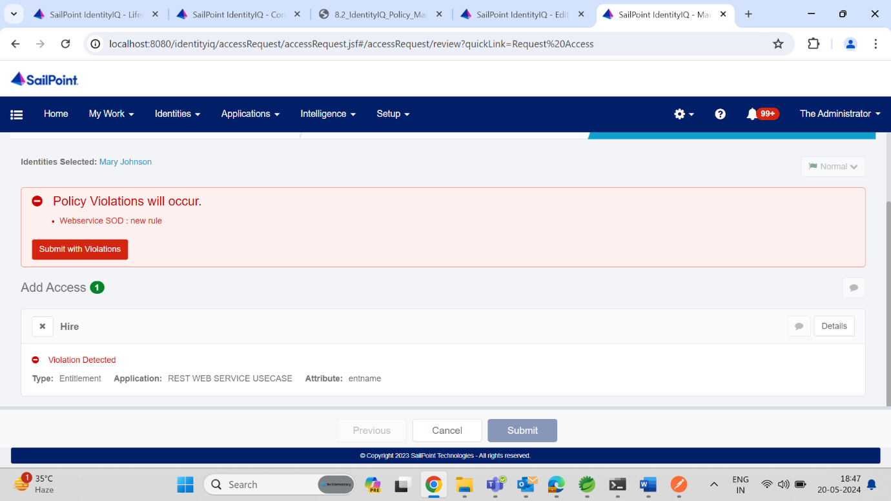

>we can also not allow to submit when there is policy violations

By changing variable “allowRequestsWithViolations” to false